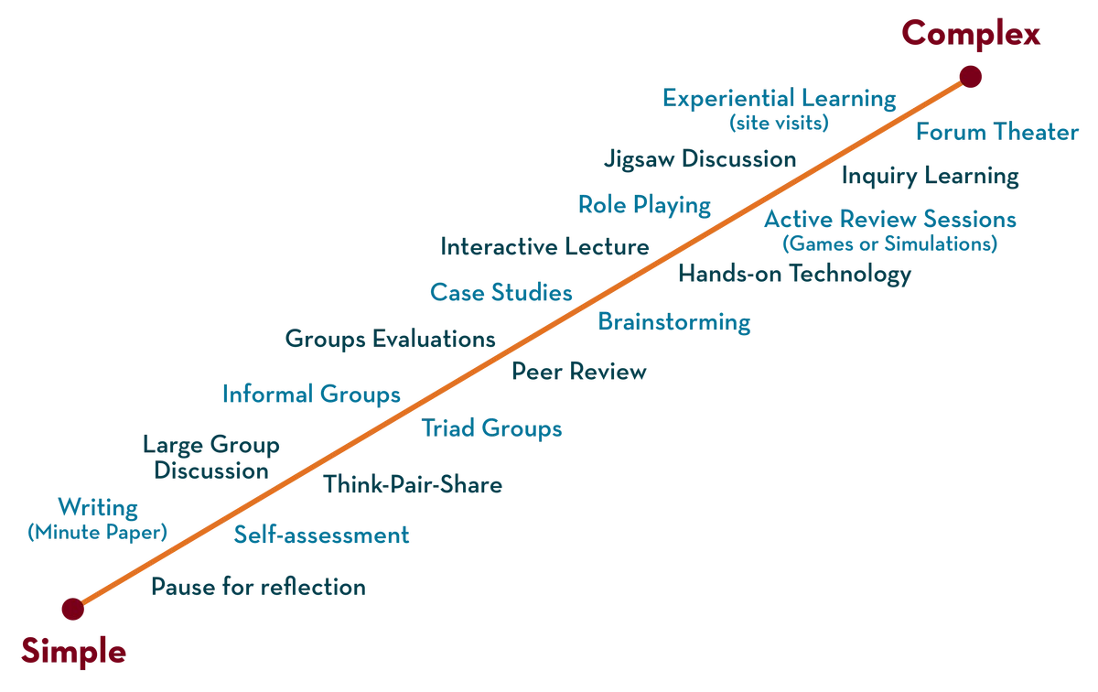

FACULTYNAME:V.NARESH SIR

NAME:KURREANUHYA

ID:2000030535

Department of CSE Honors

**VIDEO TRANSCODER**

**Topic:**

**COURSE CODE: 20CS3281AA/PA**

**COMPUTING**

**COURSE NAME: CLOUD SERVERLESS**

CREATED BY K. VICTOR BABU



2.

Summarize

3.

Describe

Describe the

Define

1.

At the end of this session, you should be able to:

LEARNING OUTCOMES

To familiarize students with the basic concept of

AIM OF THE SESSION

CREATED BY K. VICTOR BABU

4.

List out the

3.

Describe

2.

Demonstrate

1.

This Session is designed to:

INSTRUCTIONAL OBJECTIVES



Transcoder is media transcoding in the cloud. It is

smartphones, tablets and PCs.

format into versions that will playback on devices like

convert (or “transcode”) media files from their source

cost effective way for developers and businesses to

designed to be a highly scalable, easy to use and a

Amazon Elastic

AMAZON ELASTIC TRANSCODER:

SESSION INTRODUCTION

CREATED BY K. VICTOR BABU



CREATED BY K. VICTOR BABU

SESSION DESCRIPTION

STEPS TO CONDUCT THIS ACTIVITY

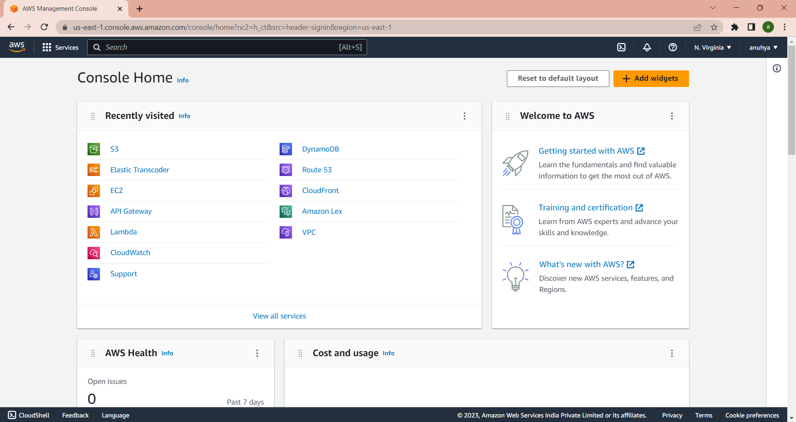

CREATED BY K. VICTOR BABU

SESSION DESCRIPTION (Cont..)

❑

STEP 1: Sign into the AWS console

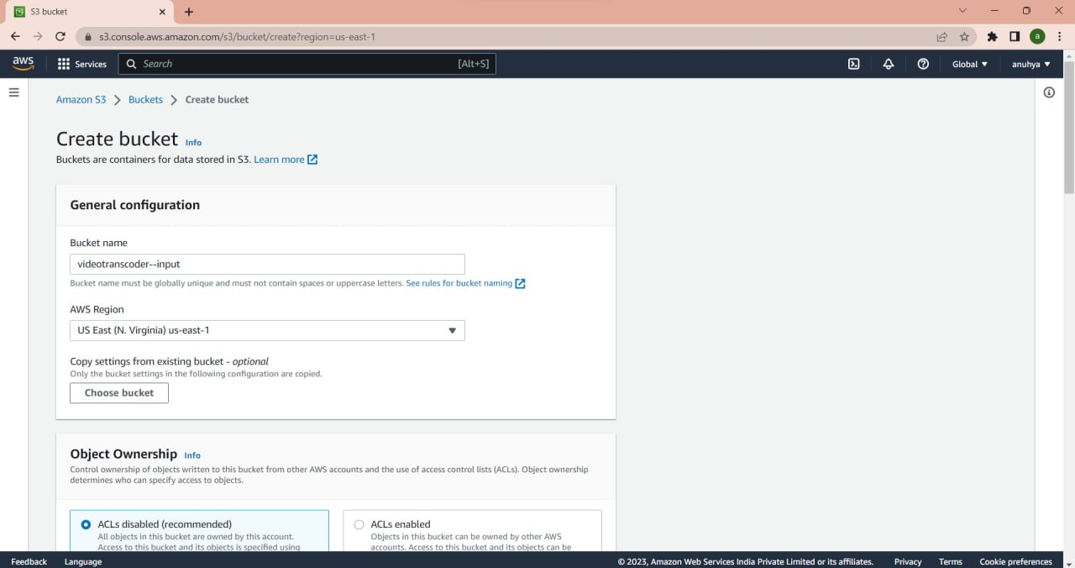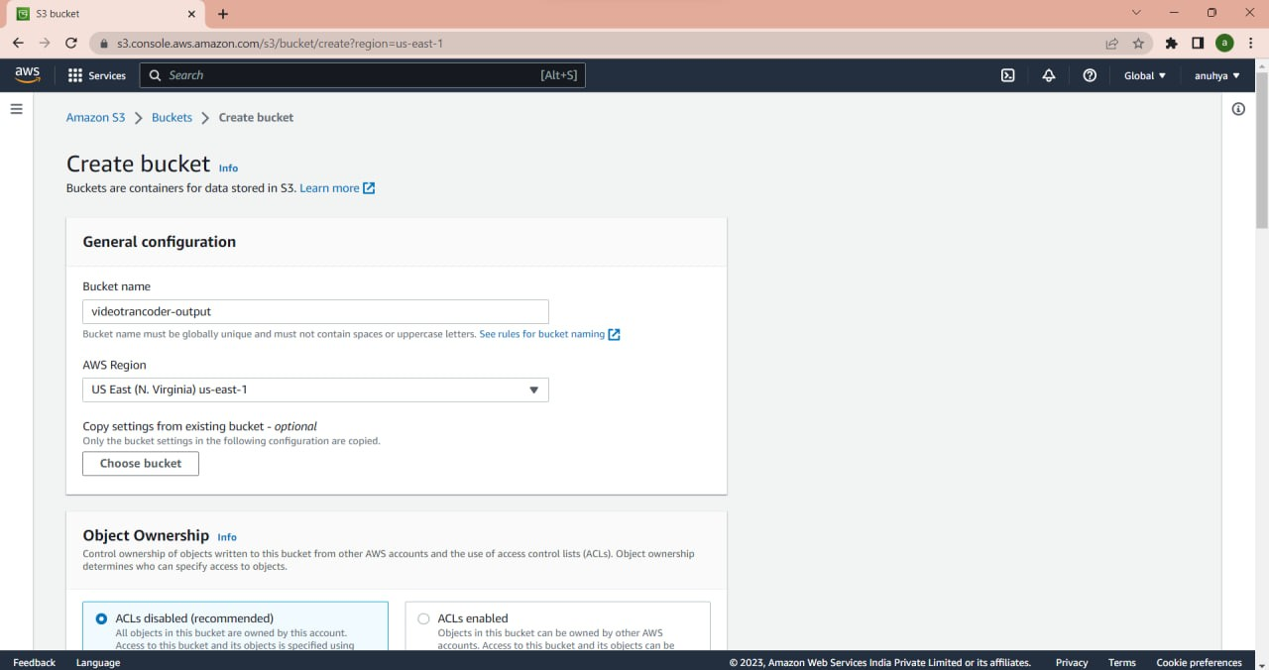

CREATED BY K. VICTOR BABU

SESSION DESCRIPTION (Cont..)

❑

STEP 2: Create Amazon S3 Bucket

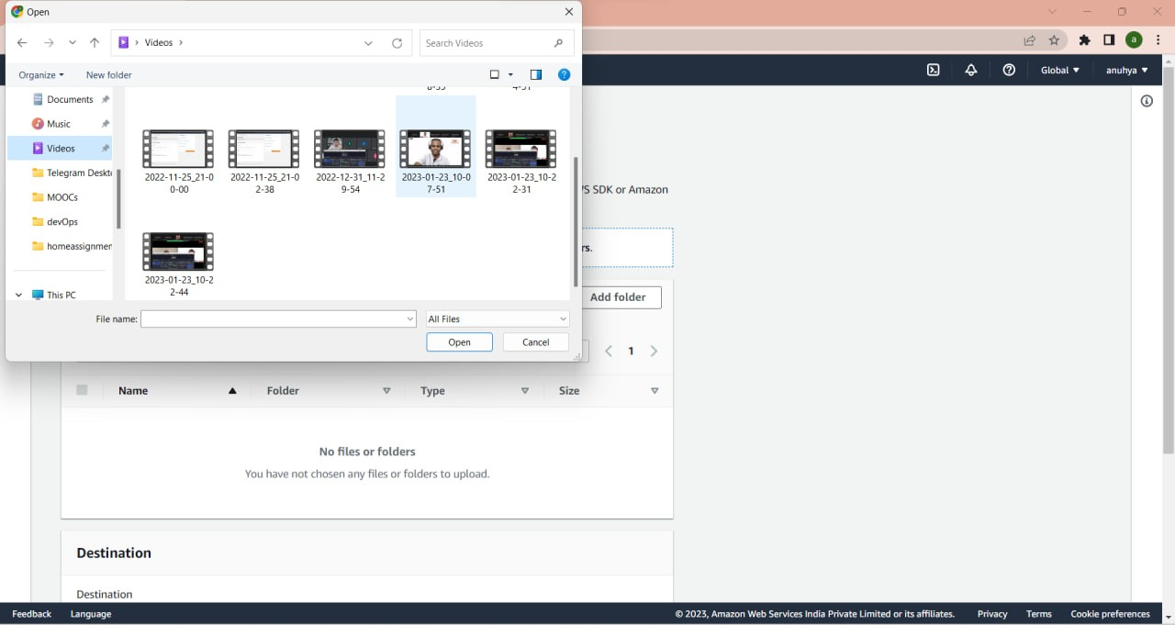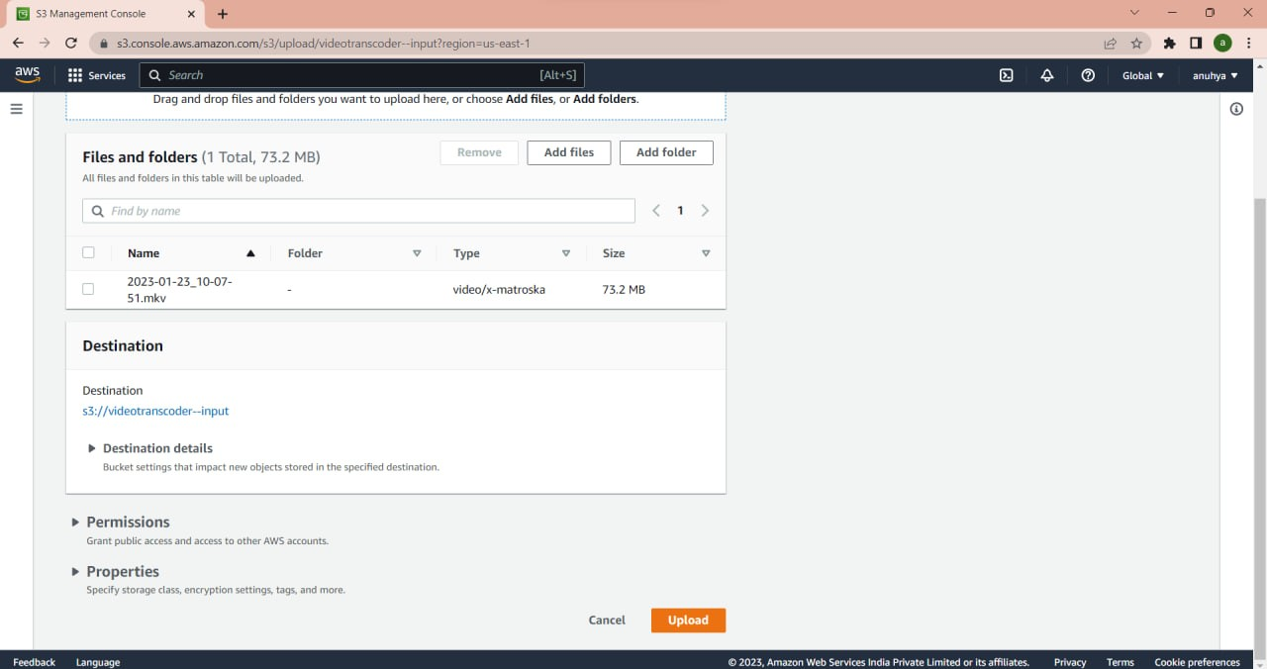

CREATED BY K. VICTOR BABU

❑

Upload the file to be transcoded to the input bucket



CREATED BY K. VICTOR BABU

❑

Create New Pipeline

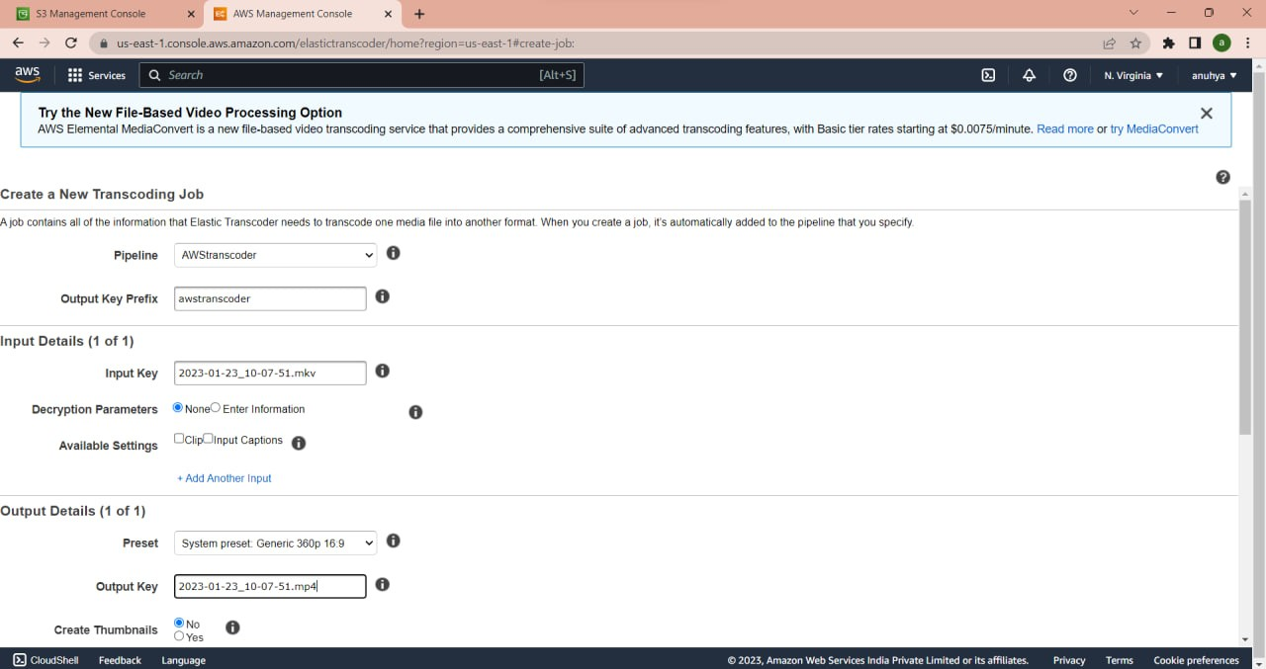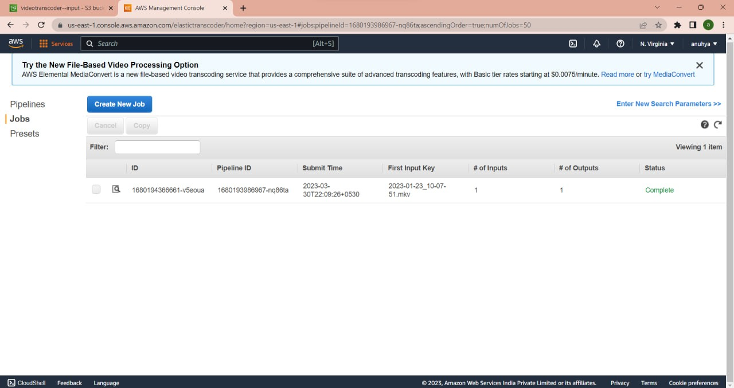

CREATED BY K. VICTOR BABU

❑

Create New Job and open jobs select the pipeline and search

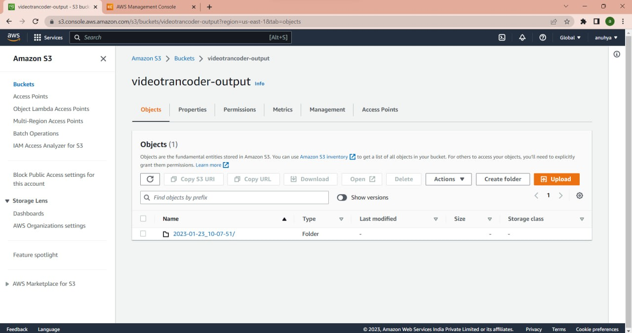

CREATED BY K. VICTOR BABU

❑

Final output



CREATED BY K. VICTOR BABU

REFERENCES FOR FURTHER LEARNING OF THE SESSION

**Sites and Web links:**

1. https://aws.amazon.com/elastictranscoder/



CREATED BY K. VICTOR BABU

**THANK YOU**